Internal Referral to Dental

- In the patient chart, click the option next to “Search for new orders”.

- Click on Internal Referrals under Referrals.
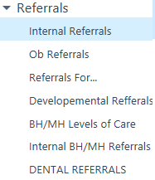

- Click once to choose appropriate internal referral depending on your department. Click Accept.
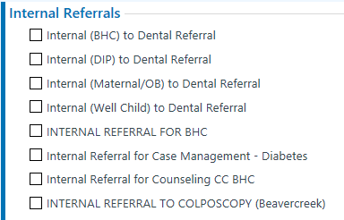

- F2 through options to populate required fields.
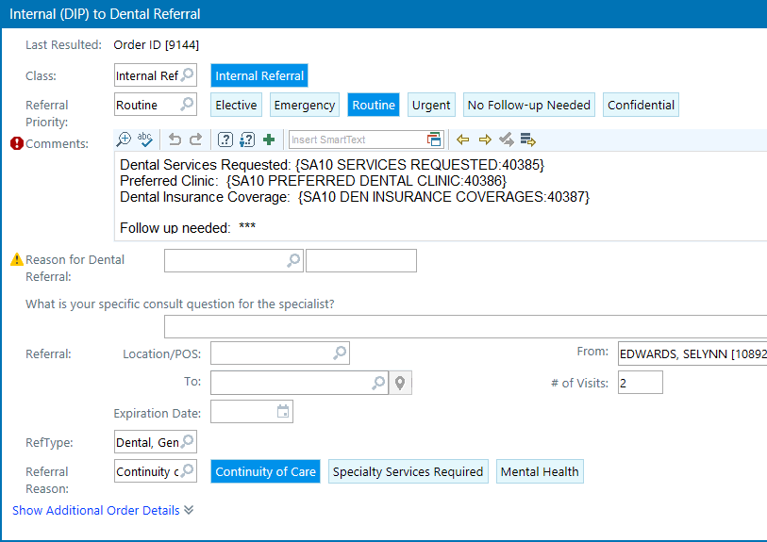

- Choose Reason for Dental Referral.
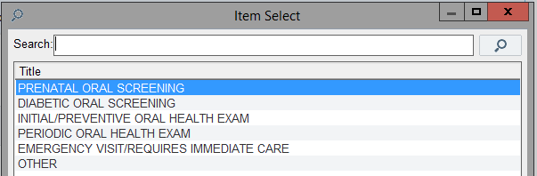
- Choose Location/POS. if you don’t see the preferred clinic location below, you may type the name into the search field.
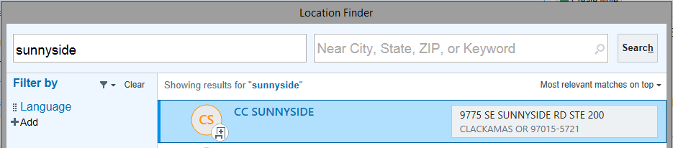
- Choose To.

Sign Orders.

