Baby Day Immunizations Integration Communication Plan | 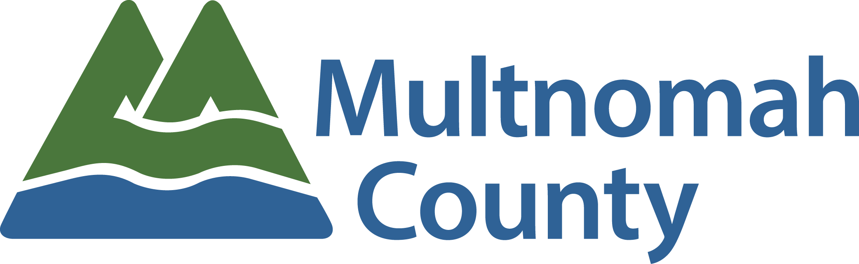

Document Audience | Baby Day Immunizations Integration Workgroup
Key Contacts | Project Manager
Last Updated | 10.03.18

Background
- Though some oral health integration work is underway with ICS, both disciplines remain largely siloed without an overarching integration strategy.
- The dental program received funding from CareOregon Dental to better integrate primary care and dental services.
- The funding will support the planning, implementation and evaluation of a two-year grant to pilot giving vaccinations to children age 0 - 3 at dental Baby Day clinics.

Communications Objectives
- Awarding of funding successfully announced to directors in an effort to strengthen communication and strategic integration efforts at leadership level.
- Unified message about the importance of integration work conveyed to primary care and dental clinic leadership by program directors.
- Dental Baby Day staff and primary care staff have understanding of project scope and impact related to patient care.
- Patients are aware immunizations will occur in Baby Day settings and are able to communicate about and support effort.

Communications Ground Rules
- Since change may be perceived as large, communications will use change management best practices: inspire (connect to mission), protect (protect staff from unnecessary or extra information), stabilize (emphasize what is staying the same).

Evaluation
- Leadership will revisit communications plan at each DPCI meeting to review status and update as needed.

Communications Objectives
Stakeholder  or Audience | Message and  Key Points | Expected Outcome  of Communication | Method | Timeline | Who | Status
SLICS | - Integration is key priority for CareOregon, State and ICS moving forward  - Leadership are champions of the work  - Immunizations will begin at dental Baby Day clinics | - Increased collaboration and partnership across programs  - Unified understanding of importance of integration  - Awareness of pilot integration project & associated timeline | Email | October/November 2018  COMPLETE | Project Support | 6.28: sent email to support staff; f/u on 8.15.18 - will present at SLICS in October.
ICS Managers & Supervisors | - Integration is key priority for CareOregon, State, and ICS moving forward  - Important to socialize project with clinic staff  - Immunizations will begin at dental BabyDay clinics | - Leadership champions identified  - Unified understanding of importance of integration  - Awareness of pilot integration project & associated timeline, and ability to share with staff | In person at PCLT | August 22 2018  COMPLETE | Project Manager | 6.28: sent email to Support staff for July mtg; 6.29: Aron f/u with Anna; 7.11: AG to attend PCLT in August
ICS All Staff | - Integration is key priority for CareOregon, State, and ICS moving forward  - Immunizations will begin at dental BabyDay clinic | - Understanding of initiative and importance  - Familiarity of project timeline | Email | September 2018  COMPLETE | Len, Tasha | 6.28: sent email to Vanetta/Adrienne; 9.11: Dental/PC to send email to program.
Baby Day Team | - Integration is key priority for CareOregon, State, and ICS moving forward  - Immunizations are now available at Baby Day clinics  - One visit will meet multiple health needs!  - Eligible child can get vaccinated on site | - Understanding of initiative and importance  - Familiarity of project timeline  - Understanding of workflow/implementation plan | In person | Sept 2018  COMPLETE | Courtney, Aron, CMA | 6.28: On agenda for Sept 26 All Baby Day mtg
Eligible Baby Day Dental Patients | - Immunizations are now available at Baby Day clinics  - One visit will meet multiple health needs!  - Eligible child can get vaccinated on site | - Understanding of initiative and importance  - Knowledge of new services available at Baby Day visits | Baby Day outreach, recruitment, in-person dialogue, Website, Social media | August 2018  IN PROGRESS | CMA, Courtney
Community Partners | - CareOregon Medical & Dental  - OPCA  - OrOHC  - NWRPCA | - Understanding of initiative and importance  - Familiarity of project timeline | Email, e-newsletter | October 2018  IN PROGRESS | Aron, Tasha | 8.16.18 - drafted NWRPCA article; 10.03.18 - revising NWRPCA enews; sent to OrOHC; will send to CO
Other MCHD Programs | - Immunizations are now available at Baby Day clinics  - One visit will meet multiple health needs!  - Eligible child can get vaccinated on site | - Understanding of initiative and importance  - Knowledge of new services available at Baby Day visits | Email, HD Facebook/Twitter feed | August 2018  IN PROGRESS | Aron
Community Health Council | - One visit will meet multiple health needs!  - Will not impact any other operational component of Baby Day (e.g., hours, days) | - Understanding of initiative and importance  - Knowledge of new services available at Baby Day visits | In person | June 2018, September 2018  COMPLETE | Len, Tasha | 6.28: Len/Christine gave update at June CHC Retreat; will f/u with status update in Sept/Oct
All MultCo Staff | - Immunizations are now available at Baby Day clinics  - One visit will meet multiple health needs!  - Eligible child can get vaccinated on site  - Innovation & quality improvement | - Understanding of initiative and importance  - Knowledge of new services available at Baby Day visits | Wed Wire, Website | Sept 2018  COMPLETE | Aron | Aron drafted WW article on 8.16.18; 9.11.18: sending to WW this week; 10.03.18: published on 9.26 & MC Comms attended first day of immies and will do follow up story

Talking Points to Support Communications

- We are Integrated Clinical Services - taking an integrated approach to care assures clinical quality, safety, and efficiency in our work, and improves the overall patient experience and community health outcomes. It is in our strategic framework. It is our vision statement.
- Reaching State vaccination targets is of high priority; 2017 target was met by 1 patient.
- Offering multiple services in one visit is patient-centered.
- This work helps strengthen a culture of innovation and integration at MCHD.
- Approximately 20% (1 in 5) of eligible children at Baby Days are not up to date on vaccinations.

