Project Charter  Integrated Clinical Services Division | 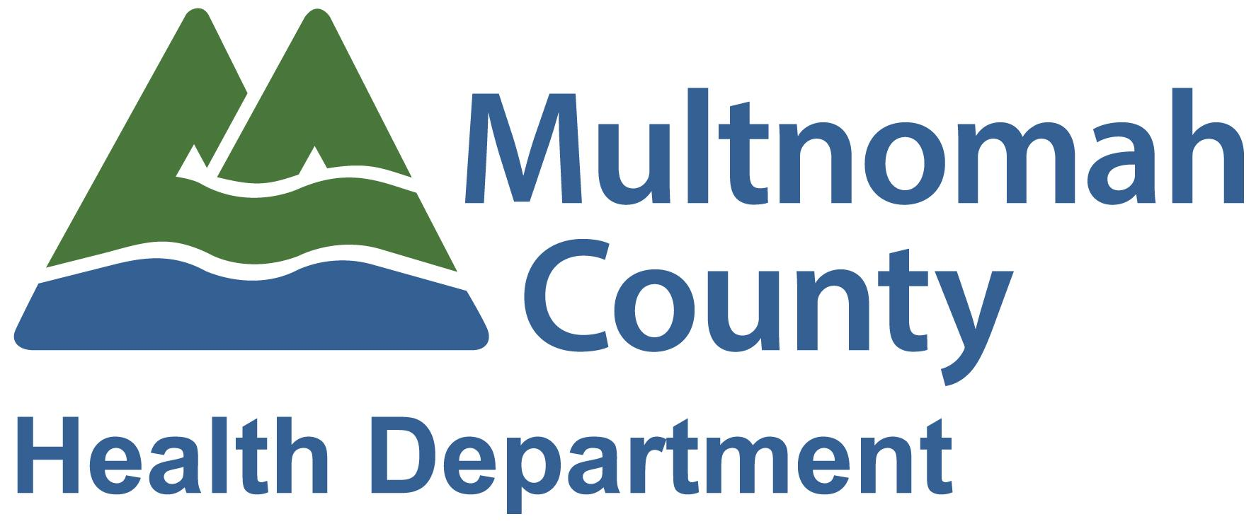

Project | Baby Day Immunizations Integration Project
Project Sponsor(s) | (name), Dental Director; (name); Primary Care Services Director
Project Manager | (name), Senior Program Specialist
Primary ICS Program | Dental
Approximate Budget | $283,532
Prepared By | Senior Program Specialist
Last Updated | May 24, 2018

Project Overview and Background
MCHD operates a robust health center program that serves over 70,000 patients annually, nearly 28,000 of whom receive dental services. Five health center locations have co-located primary care and dental clinics and a sixth will have co-located clinics in 2018 with the opening of North Portland dental. The proposed project will improve medical and dental care by supporting the infrastructure to develop, pilot, and evaluate integration, access to care, and care coordination strategies. Phase 1 (April 1, 2018 - March 31, 2019) includes 3 months of start up and 9 months of implementing giving immunizations (including flu shots) at dental’s Baby Day Clinics at East County Health Center, Northeast Dental Clinic, Southeast Dental Clinic and Rockwood Dental Clinic. A target of 30 children per month will receive immunization, with 125 parents receiving vaccination education. Phase 2 (April 1 - March 31, 2020) will include 12 months of implementing immunizations at the above clinics. A target of 60 children per month will receive needed immunizations, with 300 parents receiving vaccination education.

Project Deliverables

- Convene Immunization Workgroup
- Hire Certified Medical Assistant (CMA) to provide immunizations in Baby Day clinics; Health Clinic Supervisor to provide clinical supervision
- Develop implementation workflows for administering immunizations
- Develop quality assurance/improvement plan
- Begin providing and evaluating the administration of immunizations at Baby Day Clinics
- Improved communication and collaboration between Dental program and Primary Care program
- Education materials for parents/guardians about immunizations and related schedule
- By March 31, 2020, 80% of children who are not up-to-date on immunizations and are MCHD primary clients will receive immunizations during Baby Day Clinics.

Strategic Alignment
This project most closely aligns to the ICS Strategic Value of:
Engaged, Expert,  Diverse Workforce | Fiscally Sound  and Accountable | Person-Centered and Culturally Relevant | Quality  and Safety

Current and Future States
Current State  Triggering Problems/Opportunities | Future State  Project Measures and Targets
- Different electronic health records used by primary care and dental make integration efforts difficult  - Limited dedicated resources to lead integration efforts due to fiscal constraints  - Evolving priorities by external stakeholders providing funding of project  - Oral health and primary care remain mostly siloed, despite limited existing oral health integration efforts within primary care  - Demands placed on primary care and dental make it difficult to have consistent integration goals ongoing | - Strengthening of integration initiatives and related internal capacity  - Children receive immunizations during dental visits  - Improved health outcomes of MCHD patient population  - Exploring further ways to integrate primary care and dental services (e.g., bi-directional care)

Scope
Scope - Included | Scope - Excluded
- Immunizations at dental Baby Day clinics  - Electronic Health Record scrubbing  - Insurance scrubbing  - Outreach to parents  - Health education for parents  - EHR documentation  - Scheduling WCC visits | - Oral health integration into pharmacy, lab, corrections health, school based health centers  - Providing immunizations chairside in dental clinic (outside of Baby Day)  - Non-MCHD primary care patients  - MA scheduling new patient appointments

Related Projects:
- Existing East County Integration/First Tooth program
- Referrals from PC to Dental Baby Day

Roles and Resources
Role | Name | Expectations / Needs | Supervisor Approval
Certified Medical Assistant | Name | Plan for and provide all immunizations to eligible children at Baby Day clinics
Project Manager | Name | Lead all phases of project work; responsible for meeting timeline and deliverables
Workgroup Member | Name | Ultimately responsible for success of grant; lead decision-maker for dental clinical components of integration
Workgroup Member | Name | Decision-maker for dental operational components of integration
Workgroup Member | Name | Decision-maker for primary care clinical components of integration
Workgroup Member | Name | Decision-maker for primary care operational components of integration
Workgroup Member | Name | Decision-maker for primary care operational components of integration
Workgroup Member | Name | Reviews and approves all quality-related strategies and decisions
Workgroup Member | Name | Supports all clinical needs related to immunization workflow; provides oversight
Workgroup Member | Name | Develops achievable implementation workflow for integration of immunizations at Baby Day clinics and oversees on site operations
Workgroup Member | Name | Supports all CSI related components of implementation workflow and reporting
Workgroup Member (ad hoc) | Name | Offer strategic leadership and guidance related to integration efforts

Decision-Making Method:
Primary: Consensus
- All members voice their opinion
- All members respect decision of the group
- All members support and help implement
Secondary: Delegate with constraints
- Leader defines and clarifies decision
- Leader defines constraints (e.g., budget, timelines)
- Leader delegates in concert with DOM
Tertiary: Leader Decides

Budget / Resources: 90-minute meeting every month or every other month

Timeline

Milestone | Completion date
Phase 1 (04/01/18 - 03/31/19)
Workgroup Leadership Team established with charter and meeting schedule for project period | 04/01/18 and ongoing
Hire Certified Medical Assistant | 08/31/18
Develop workflows, work plans, and performance management/quality plan | 09/31/18
Train East County Baby Day staff & CMA | 08/31/18 - 09/30/18
Implement and continue to refine performance management/quality plan | 10/01/18 and ongoing
Submit quarterly reports and annual technical reports |  | 12/01/18 and ongong
Pilot CMA providing immunizations at East County Baby Day Clinics |  | 10/01/18 - 03/31/19
Integrate quality improvements into work flows as needed |  | 10/15/18 and ongoing
Train staff at Rockwood, Northeast, and Southeast health centers |  | 11/15/2018 – 12/15/2018 (RWDC)  12/15/2018 – 1/15/2019 (NEDC)  1/15/2018 – 2/15/2019 (SEDC)
CMA begins providing immunizations at Baby Day at other three health centers |  | 1/1/2019 – 3/31/2019  2/1/2019 – 3/31/2019  3/1/2019 – 3/31/2019
Modify workflows and work plans based on Phase 1 results and staff and client feedback |  | 04/01/19 - 03/31/19
CMA provides immunizations at East County, Rockwood, Northeast, and Southeast |  | 04/01/19 and ongoing
Implement quality improvement exercise, including gathering staff and client feedback, and modify workflows as needed |  | 08/15/19 - 09/30/19
Sustainability plan developed |  | 10/01/19 - 1/31/19
Sustainability plan implemented |  | 02/01/20 and ongoing
Draft final report, including project sustainability, and disseminate to local stakeholders |  | 03/01/20 - 03/31/20  03/31/20
300 children reached at 4 health centers in Phase 2 through Immunizations at Baby Day
Remaining infrastructure components completed/implemented

Communications
The Project Manager will develop a detailed communications plan to assure understanding and awareness of the work, as well as to share key messages with staff, clients, and partners when needed.

Assumptions, Constraints and Risks
Assumptions: Project will be able to be sustained without resources at the end of the grant period; project participants will be able to be pulled together for meetings as needed; work will be aligned with ICS strategic framework.

Constraints: Inadequate time for meetings; other IT Pipeline priorities; limited data reporting resources; budget limitations beyond grant period; limited space at Baby Day clinics

Risks: Added chaos or disruption to Baby Day clinic

Change Management
Changes to the project charter, deliverables or project scope, schedule or cost require the written approval of the project sponsor. The approval will be documented and retained by the ICS Project Management Office.

Approvals

____________________________________ ____________________________________
SLICS Sponsor Date Project Manager Date

Definitions and Acronyms
- Provider: Dentist or Hygienist
- ICS - Integrated Clinical Services
- MCHD - Multnomah County Health Department
- PM - Project Manager
- SLICS - Senior Leadership for Integrated Clinical Services
- SME - Subject Matter Expert

Version History
Version Date | Sections / Reasons Changed | Authors | Approved By Sponsor
08.16.17 | Original | All
09.13.17 | Timeline for immies implementation changed; | Aron
04.06.18 | Charter updated to reflect final FRP | Aron
04.25.18 | Updated DPCI membership list | Aron
05.24.18 | Added Gaby Carrillo to workgroup; changed DPCI to “workgroup”; added comments to document; adjusted project title | Aron
06.29.18 | Updated timeline; replaced Gaby with Jonathan on membership list; added targets to background/overview | Aron
10.11.18 | Added making WCC visits to in scope | Aron

