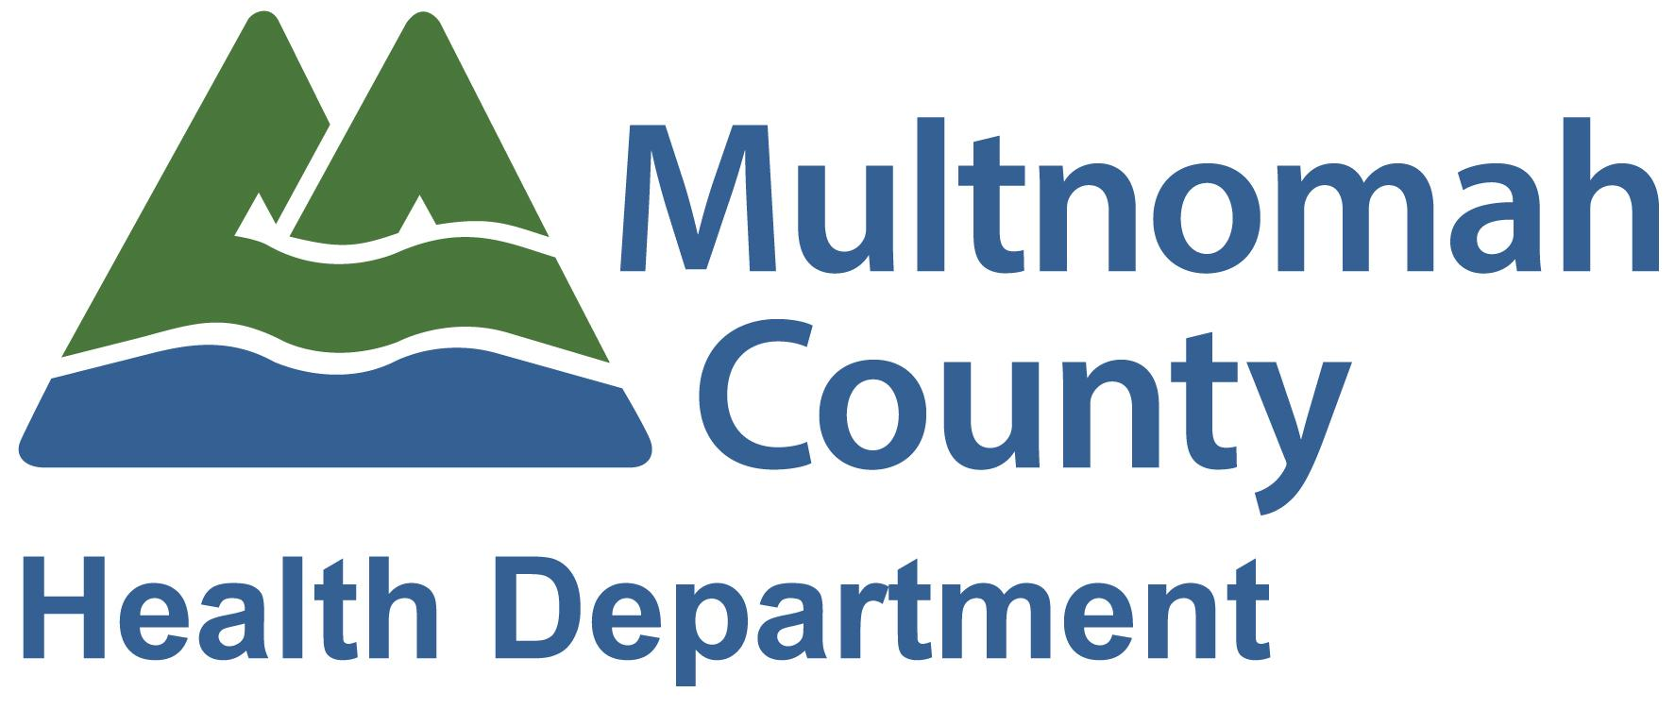
Outreach Toolkit for Baby Day Immunization Visits
September 2018
- Utilize the Baby Day Immunization Clinic Scheduling Workflow to identify eligible clients for Baby Day Immunization visit or WCC.

Scripting for Immunization Eligible Baby Day Clients
If patient answers the phone:
Hi. My name is [name], and I’m calling from [clinic name] Baby Day Program. Can I please speak to the parent/guardian of [child’s name]? I wanted to let you know that we have an exciting opportunity where we are now providing immunizations at our Baby Day Dental appointments. Provide vaccine health education to parent/guardian. I see that [child’s name] is overdue for some of their immunizations, and was wondering if you would like to schedule an appointment right after your Baby Day visit to get those taken care of?

If yes:
- I see that your Baby Day appointment is [date/time of Baby Day visit], so would [time right after Baby Day visit] work for you?
If no: If able, find out the reason for the barrier to care.
- Provide parent/guardian with the refusal video information.
- Use proper workflow to record in Epic.
- Let them know that we are looking forward to seeing them and their child at their Baby Day visit on [date and time of visit].

If no answer:
Hi. My name is [name], and I’m calling from [clinic name] Baby Day Program. I’m calling to let you know about an exciting new opportunity at our Baby Day program, where we will now be able to provide immunizations at the end of our visits. I see that [child’s name] is overdue for some of their immunizations, and am calling to see if you are interested in scheduling an appointment to get them caught up right after their Baby Day appointment on [date/time of Baby Day visit]. Please call me back at [cell phone number] if you are interested in scheduling, or if you have any questions about this new service. Thank you.

Scripting for Scheduling Baby Day Clients for WCC: for clients that are overdue for immunizations and have a WCC due, but not scheduled, within the next month

If patient answers the phone:
Hi. My name is [name], and I’m calling from [clinic name] Baby Day Program. Can I please speak to the parent/guardian of [child’s name]? I see that [child’s name] is overdue for their well child check and some of their immunizations. Provide information on importance of receiving well child checks and immunizations. I am calling today to see if we can schedule [child’s name] next well child check and get caught up with their immunizations.

If yes:
- Check to see if there are any available WCC slots after their Baby Day appointment. If yes, suggest that date and time. “I see that your Baby Day appointment is scheduled for [date/time of Baby Day appointment]. We have an available appointment at [time of appointment]. Will this time work for you?

If yes:
- Schedule appointment

- If no available slots after Baby Day appointment – “Our first available appointment is on [date/time]. Would this work, or is there a day or time that works better for you?

If no:
- Would you be interested in scheduling just an immunization visit right after your Baby Day appointment?

If yes:
  - I see that your Baby Day appointment is [date/time of Baby Day visit] - would [time right after Baby Day visit] work for you?

If still no:
  - Provide parent/guardian with the refusal video information.
  - Use proper workflow to record in Epic.
  - Let them know that we are looking forward to seeing them and their child at their Baby Day visit on [date and time of visit].

If no answer:
Hi. My name is [name], and I’m calling from [clinic name]Baby Day Program. I am calling today about [child’s name]. I see that they are overdue for their well child check, as well as some of their immunizations, and wanted to go ahead and schedule those appointments for you. Please call me back at [cell phone number] when you get a chance. Thank you.

- Data Tracking – please enter all calls made on the Baby Day Immunization Outreach Tracker.

