NARA Dental triage sheet: What is a Dental Emergency?

- Facial Swelling
- Child in Pain
- Pregnant woman in pain
Dental Emergency (same day care)

- Patient in acute pain
- Severe trauma to teeth

- Mild or moderate pain
- Minor dental trauma
Urgent Dental Care
(24-48 hours)

Routine Dental
Care
(2-6 weeks)

When should a patient be sent directly to the ER?
- Facial swelling that restricts swallowing or extends beyond the area of the tooth (extends to the eye, pharynx, sublingual or submandibular spaces)
- Symptoms of systemic infection such as malaise, fever
- Trouble breathing
- Trouble opening (trismus)
- Uncontrolled bleeding
- Facial trauma that includes facial/oral lacerations or injury to the facial bones

Swelling

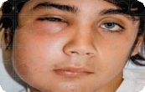
Facial swelling extending beyond the area of the tooth, symptoms of malaise, fever
•Send patient to the Emergency Room

Localized facial swelling
•Emergency (same day) dental care

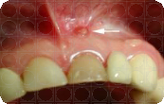
Dental abscess with no facial swelling
•If tooth is symptomatic (pain): urgent (within 24-48 hours) dental care
•If tooth is asymptomatic: routine (within 2-6 weeks) dental care
Trauma

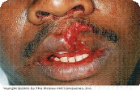
Orofacial trauma to structures other than teeth: lips, tongue, cheek, alveolar bone
- Send patient to the Emergency Room

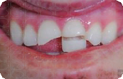
Severe tooth trauma
- Urgent (within 24-48 hours) dental care
- If patient is child, Emergency (same day) priority

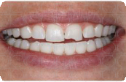
Minor tooth trauma (chipped tooth, broken filling)
- Routine (within 2-6 weeks) dental care
There is no “one size fits all” approach to triaging dental emergencies. This information is
meant as a guide for you when deciding how best to care for your patients’ dental needs. When in doubt, please call the Dental Clinic to speak with a dental provider during normal business hours. For the general public, we provide a limited number of emergency walk-in appointments daily from 7:30-10 am on a first come, first served basis.

