ORAL HYGIENE RECOMMENDATIONS
BRUSH 2 TIMES A DAY AND FLOSS 1 A DAY

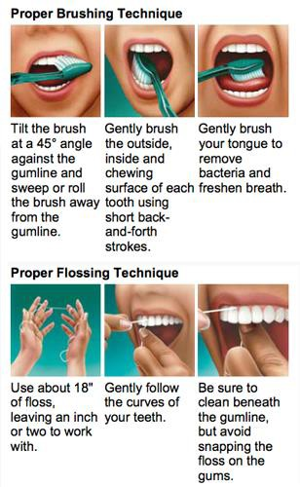

NARA Dental 12750 SE Stark ST, BLDG E
Portland, OR 97233
971-347-3009

