Dental Referral via In Basket Message

- In the Epic In Basket To: field, type in P SA10 DENTAL NAVIGATOR or click the magnifying glass to search for the Navigator pool.

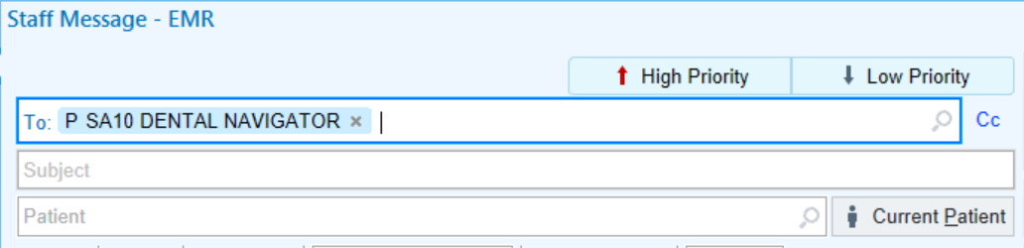

- In Search, you may type in SA10 NAVIGATOR to locate the Dental Navigator pool.
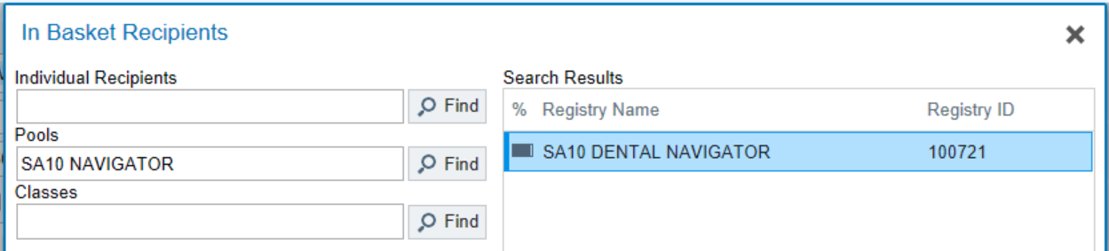

- In the Subject field, type “Internal Referral to Dental”.

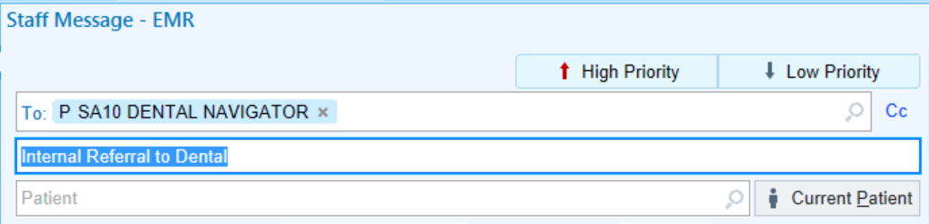

- Choose patient by Patient Search or Recent Patients.
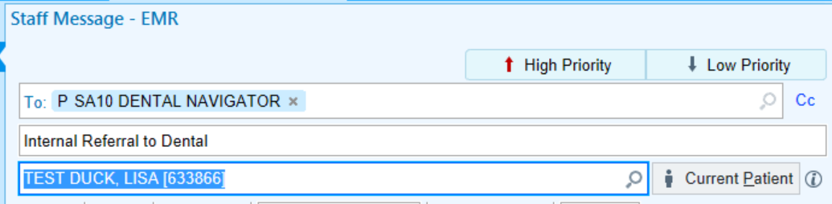

- Free text any pertinent information. Helpful information can be what department the patient is being referred from (OB/Diabetes Integration Project/BHC, Well Child), insurance information (if known), and action requested (please call patient or appointment already made).
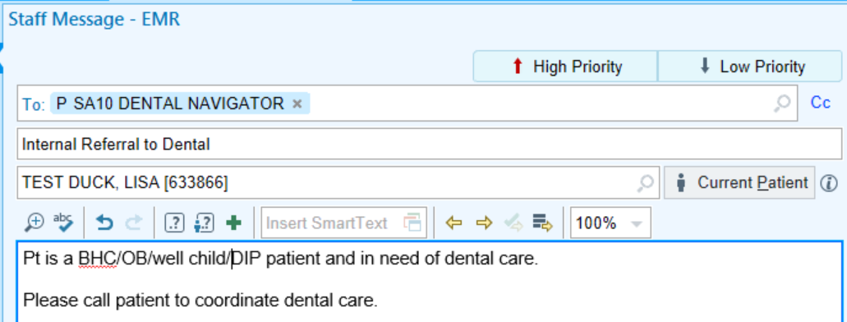

Click Send.

