NARA Dental Outreach Policy and Procedures Manual

Table of Contents

Services Provided - 2 -
Locations - 3 -
Contact Personnel - 4 -
Visit Schedule - 5 -
Scheduling Process - 6 -
Procedure Guidelines - 9 -
Referral Process (Clients in Treatment) - 14 -
Educational Talk Guidelines - 16 -
Appendix - 17 -

Services Provided

Services listed below are not offered at all outreach locations. Services with a * are offered at our Adult and/or Youth Residential facilities only at this time.

Current Services
- Limited oral assessments/screenings to determine patients dental needs
- Limited exam by Dentist*
- Comprehensive exam*
- Periodontal Exam*
- Radiographs*
- Adult and Children (including toothbrush prophy) Prophylaxis
- Full Mouth Debridement*
- Scaling and Root Planing*
- Periodontal Maintenance*
- Temporary Restorations*
- Permanent Restorations*
- Indirect Pulp Caps*
- Extractions*
- Oral Health Education
- Fluoride varnish applications
- Silver Diamine Fluoride
- Sealants

Locations

Adult Residential
17645 NW St. Helens Highway, Portland, OR 97231
Phone: 503-621-1069
Fax: 503-621-0200

Residential Child Development Center (CDC)
Located within Adult Residential
17645 NW St. Helens Highway, Portland, OR 97231
Phone: 503-621-1069
Fax: 503-621-0200

Outpatient Child Development Center (CDC)
1631 SW Columbia St., Portland, OR 97201
Phone: 503-231-2641
Fax: 503-231-1654

Youth Residential Treatment Center (YRTC)
620 NE 2nd St., Gresham, OR 97030
Phone: 971-274-3757

Indian Health Clinic
15 N. Morris St., Portland, OR 97277
Phone: 503-230-9875
Fax: 503-230-9877

Native American Youth Association (NAYA)
5135 NE Columbia Blvd, Portland, OR 97218
Phone: 503-288-8177

Siletz Head Start
12727 SE Market St, Portland, OR 97233
Peace Church of the Brethren
(Bottom level of church, park in back, go down the walkway)

Contact Personnel

This page used to list individual contact information for personnel.

Visit Schedule

Adult Residential
Every Wednesday
- Treatment starts at 7:15am and ends at 4:45pm
- Educational Talk are every other week and begin at 1:30pm

Residential Child Development Center (CDC)
One-two times a month-based off of new arrivals
- Exams/Prophy/SDF/Fluoride application are completed onsite

Outpatient Child Development Center (CDC)
One Thursday a month
- Leave the clinic around 9:45am
- Assessments start between 10:15am-10:30am

Youth Residential Treatment Center (YRTC)
Two Thursday’s a month beginning at 9:00am

Indian Health Clinic
Diabetes Clinics- held one Saturday a month (does not happen every month)
- Starts at 8:00am, usually finished around 12:00pm

Native American Youth Association (NAYA)
- Spring Break Camp- March
- Summer Camp-July/August
Siletz Head Start
Quarterly
- Arrive at 9:30am

Scheduling Process

Adult Residential (New Intakes)
Each week, the Residential Clients excel spreadsheet is updated based on the latest Residential Clients Census (currently the Dental Medical Integration Coordinator has access). Once this is completed, all new arrivals are scheduled to have screenings completed. Upon the initial screening, the priority level is determined based on priority guidelines (see Screening Priority Guide in Appendix). Level of severity is ranked a 1, 2, or 3.
Once a patient has been screened, the information gathered at the screening will need to be updated in the Residential Client excel spreadsheet.
All clients ranked at a *Level 1 would be scheduled for the recommended exam at the soonest available appointment.
All clients ranked at a *Level 2 would be scheduled for the recommended exam after all priority 1 clients have been seen.
All clients ranked at a *Level 3 would be scheduled for the recommended exam based on their date of intake as appointments become available.
- Limited Exam- Schedule in either Dentists 1st chair Residential client spot or an appointment at Residential for 1 hour
- Comprehensive Exam- Exams can either be scheduled in 2nd chair in Dental Clinic for either provider or can be scheduled with EPDH at Residential for 1 hour.
Residential appointments scheduled at the Dental Clinic need to be marked REZ in front of the appointment description. Residential appointments scheduled onsite at Residential need to be marked @Res in front of the appointment description. See example below:
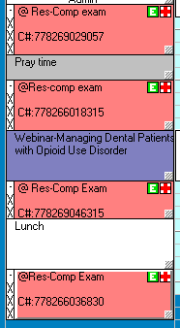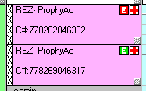
Once a patient has had an exam completed, the information gathered at the exam will need to be updated in the Residential Client excel spreadsheet. Under the column Treatment needed, list the first priority treatment (filling, extraction or referral) as well as recommended cleaning type (Prophy or SRP’s). Turn the treatment or cleaning needed red.
Treatment & Cleaning Appointments for Adult Residential Clients
Once a patient has completed a comprehensive exam the doctor will create a treatment plan of restorations, extractions and cleaning recommendation (may need perio charting at the cleaning appointment). Treatment plans will be completed by the provider that diagnosed during the exam.
- Fillings & Extractions- Schedule with assigned provider in their 1st chair for 1 hour (either with a provider at dental clinic or a provider at Residential)
- Cleanings- Patients can either be scheduled at Dental Clinic or at Residential for one hour in hygiene chair. Please keep in mind that Hygienist at Dental Clinic can only see 3 SRP’s a day and Hygienist at Residential can only see 2 SRP’s a day (hygienist prefers to have an assistant during SRP’s at Residential due to equipment restrictions)
Once a treatment appointment is created for a client, please notate under the treatment appointment column the date of the appointment and location (turn the writing color red). Turn the writing black under anything that is scheduled. Once a cleaning appointment is created for a client, please notate under the cleaning appointment column the date of the appointment and location (turn the writing color red). Change the color of cleaning under “Treatment needed” black once cleaning has been scheduled.
If a client has children onsite, it is ideal to have all appointments completed onsite at Residential so that parent can have child care coverage.
***The Residential Client excel spreadsheet is found in the Dental Outreach folder on the share drive and should only be edited by an outreach team member.***
Residential Appointment Slots Verbiage
Patients are seen in the dental clinic on Wednesday or Thursday mornings from 7:45am to 9:45am. Only 5 patients at a time are allowed to come from Residential due to available space on the van.
Patients are treated onsite at Residential on Wednesdays from 7:15am until 4:45pm.
What we tell the patients:
On Monday of each week there will be a new list of patient appointments posted on the medical door. If you see your name under “Dental Appointments @ Residential” with a specific time that means your treatment will be onsite at Residential. If you see your name under a date but not a specific time labeled “Driver Log,” that means you will be transported to the dental clinic for treatment. If you are unable to make your appointment please let us know immediately.
If you are scheduled an appointment in our dental clinic, you are scheduled in a spot designated for our residential clients. If you graduate or choose to leave residential prior to your upcoming appointment, your scheduled appointment will be cancelled. The appointment slots are designated for clients currently in NARA residential treatment. Please call us to schedule an appointment and inform us of your new contact information.
Back Office Verbiage:
Please ask residential clients if they know their estimated graduation date. Please inform patient of current policy if they have upcoming appointments scheduled.
Front Office Verbiage:
Scheduling next appointments- Each week there is a new list of appointments posted on the medical door at Residential on Monday afternoons with all patients’ upcoming appointments; please refer to that list to see when and where your appointment will take place. If you need to reschedule an appointment please notify Dawn, the nurse at Residential, and she will notify us.
For canceled appointments-The appointment slots are designated for clients currently in NARA Residential treatment. If you graduate or choose to leave Residential prior to your upcoming appointment, your scheduled appointment will be cancelled. Please call us with your updated phone number and address if you would like to schedule appointments outside of treatment.

Procedure Guidelines

Adult Residential

Assessments:
- Patients are scheduled for assessments generally 1-2 weeks after their arrival at Residential
  - If a patient has an existing dental provider and would like to continue care with them, no further appointments will be made to establish care with NARA Dental Clinic
- Patients can choose to decline an assessment, however, the patient cannot be scheduled for any dental services without having an assessment to determine he/she’s priority level
  - Unless patient is having a life threatening dental emergency
- Patient must complete a registration packet prior to assessment
- A brief assessment is conducted by the EPDH to determine if a patient is a Priority level 1, 2, or 3 (see Priority Level Guide in Appendix)
  - Patient is offered fluoride varnish application
- Dental Medical Integration Coordinator (DMIC) then schedules the patients based on their priority level for treatment onsite at Residential or at the Dental Clinic

Comprehensive, Periodic, or Limited Exams:
- All patients will receive a comprehensive exam before hygiene services will be scheduled, unless FMD is needed
- A patient in pain will be given the option to schedule a limited exam or comprehensive exam
- Patients that receive a limited exam and completed necessary treatment to address pain will then be scheduled for a comprehensive exam
  - Limited exam should include PA, BWX, and any needed treatment planned
- Comprehensive exams should include blood pressure, FMX, perio chart, existing restorations, and any needed treatment planned and sequenced
  - If patient declines films, a comprehensive exam cannot be completed
  - Patient that states they recently had films and declines any new films will not have a comprehensive exam completed until digital records are obtained
- X-Ray Guidelines:
  - FMX taken within 5 years
  - If FMX is within the 5 years, then 4 BWX’s and 2 PA’s will be completed
  - BWX and PA for limited exam

Hygiene Services:
- Full mouth debridement is completed prior to comprehensive exam only
- Adult or child prophy (toothbrush prophy included) can be completed onsite
  - Prophy will not be completed if the patient states it has been less than 6 months since their last cleaning
- 1 quad of SRP per 1 hour appointment time can be completed onsite
  - Consent must be signed to begin SRP
  - Blood pressure taken before local anesthetic given; must be below 160/100
  - Blood glucose levels for all diabetic patients taken before local anesthetic is given; must be below 200

Preventative Services:
- Fluoride varnish applications can be applied during assessments, prophy, sealant placement, SDF placement, and/or exams
- Silver Diamine Fluoride can be applied during hygiene, restorative, or sealant appointments
  - Signed consent must be obtained from patient or guardian if under 14 y/o before first application can be applied
- Sealants can be completed during restorative or hygiene appointment
  - Fuji Triage with cavity conditioner or Clinpro with etch are used for sealant placement
    - Material choice is determined by provider

Restorative Services:
- Patients with restorative needs are prioritized based on intake date and priority level established during limited exam or comprehensive exam
- Fillings are scheduled by the quadrant, unless specified by the Dentist
- Blood pressure must be taken prior to anesthetic being delivered; must be below 160/100

Extractions:
- Patients in need of extractions are prioritized based on intake date and priority level established during limited exam or comprehensive exam
- Consent must be signed prior to starting treatment
- Blood pressure must be taken prior to anesthetic being delivered; must be below 160/100; and before the patient is dismissed
- Blood glucose levels for all diabetic patients taken before local anesthetic is given; must be below 200
- Patients receive verbal and written post-op instructions and sterile gauze packets
  - Ice packs are available if needed
- If complications arise and patient is in need of oral surgery to complete extraction, Dentist will refer to oral surgeon
  - Dentist may request a follow up appointment in the Dental Clinic

Residential Child Development Center (CDC)

- One to two times a month Dentist and EPDH will go into the CDC to provide Comprehensive or periodic exams, toothbrush prophy, fluoride varnish application, and OHI with the parent/guardian
  - Registration packet must be completed by parent/guardian prior to appointment
    - Consent for fluoride must be obtained prior to application
- If a child has restorative needs it will be at the discretion of the Dentist whether treatment will be completed onsite at Residential or in the Dental Clinic
  - Dentist will complete a Pediatric dentist referral when needed
- If a child is in need of SDF, it will be applied onsite at Residential
  - Signed consent from the parent/guardian must be obtained prior to SDF application

Outpatient Child Development Center (CDC)

- Once a month EPDH provides assessments and fluoride varnish applications
  - Consent for assessment and fluoride varnish application must be obtained prior to providing services
- Roster of clients in OP CDC is updated prior to visit via email from EPDH to Sada at OP CDC
  - Roster can be found on S-Drive under Dental-Outreach-Signed CDC Consents
- Form with assessment findings and any recommended treatment left for parent/guardian

Youth Residential Treatment Center (YRTC)

Teledentistry Comprehensive or Periodic Exams
- All patients will receive a Teledentistry comprehensive exam or periodic exam, if needed
- Teledentistry comprehensive exams should include FMX, Intraoral photos, charting of existing restorations, and CPTIN
  - Patient in full ortho will not have a comprehensive exam completed unless wires can be removed
    - If patient has a primary care dentist that coordinates with patients orthodontist only a prophy will be completed
    - If patient does not have a primary care dentist, limited exam and films will be completed, along with prophy
  - If patient declines films, a comprehensive exam cannot be completed
  - Patient that states they recently had films and declines any new films will not have a comprehensive exam completed until digital records are obtained
  - For patients who state they have had an exam within the last 6 months will not receive comprehensive care until it has been 6 months from date of service
    - Continuing care reminder is notated in YRTC roster by DMIC
- X-Ray Guidelines:
  - FMX taken within 5 years if 15 years or older
  - BWX’s and Anterior PA’s within 1 year if 14 years or younger
  - If FMX is within the 5 years, then 4 BWX’s and 2 PA’s will be completed
- Correspondence letters are completed by Dr. Ahmed after she completes patient teledentistry exam
  - DMIC emails correspondence letters to scheduling contact personnel at YRTC to inform patient if follow up treatment in the dental clinic is needed
    - DMIC will schedule patient for needed treatment in clinic
Limited ER Exam:
- Patients that are in need of a limited ER exam will be scheduled by DMIC in the clinic to complete exam and treatment
Hygiene Services:
- Adult prophy can be completed onsite
  - Prophy will not be completed if the patient states it has been less than 6 months since their last cleaning
Preventative Services:
- Fluoride varnish applications can be applied during Assessments, prophy, sealant placement, SDF placement, and/or exams
- Silver Diamine Fluoride can be applied during hygiene, restorative, or sealant appointments
  - Signed consent must be obtained from patient or guardian before first application can be applied
- Sealants can be completed during restorative or hygiene appointment
  - Fuji Triage with cavity conditioner or Clinpro with etch are used for sealant placement
    - Material choice is determined by provider

Indian Health Clinic- Diabetes Clinic

Teledentistry Comprehensive or Periodic Exams
- Comprehensive exams are started at Diabetes clinic by completing 4 BWX, 2 PA’s, Intraoral photos and an assessment form
  - EPDH will schedule patient in the Dental Clinic for an hour on the hygiene side to complete periodontal exam and determine hygiene needs
    - Patient is also scheduled for 30 minutes on Dr. Ahmed’s second chair to complete FMX, comprehensive exam, and discuss any treatment needs
  - Dr. Ahmed will review films and intraoral photos taken at the diabetes clinic, she will contact the patient to discuss her findings and remind the patient of their scheduled appointment at the Dental Clinic
- Periodic exams will include 4 BWX’s, 2 PA’s and any additional PA’s the EPDH feels are necessary to provide Dr. Ahmed with complete information
  - Intraoral photos are not needed for periodic exams
  - EPDH will schedule patient for needed hygiene (prophy/perio maint)
    - periodic exam will be completed in hygiene chair
  - Dr. Ahmed will review films and intraoral photos taken at the diabetes clinic, she will contact the patient to discuss her findings and remind the patient of their scheduled appointment at the Dental Clinic
Assessment
- If the patient is not due to for a periodic exam or declines a comprehensive exam, then only an assessment is completed

Siletz Head Start

Assessment and Preventative Services
- Registration packets with consent for treatment must be completed before any child can be treated
  - Treatment completed form left with the children’s teacher to give to the parent/guardian
- Assessments, toothbrush prophy, and fluoride varnish application are completed 4 times a year (Fall, Winter, Spring, Summer)
- Sealants are placed in the Winter after the first assessments have been completed in the Fall
  - Complete a toothbrush prophy prior to placing sealants
    - Use Fuji Triage for sealants
    - Apply fluoride varnish
    - Give child the toothbrush used for the prophy and a sticker

***If child is not cooperative do not force the sealants or any treatment, try to complete treatment at next quarterly visit***

Referral Process (Clients in Treatment)

If a patient needs treatment that cannot be completed through NARA’s Dental Clinic, a referral can be completed on patient’s behalf.

These are the current OHP Plans that NARA Dental Clinic accepts:
- MODA/ODS (non-capitated)
- Capitol Dental
- Care Oregon Dental
- Family Dental Care
- OHP Open Card
- Advantage Dental (patient has to be assigned to NARA Dental Clinic for a referral to be completed)

Please follow the steps below:
- Check patient’s insurance plans
- If the patient currently has a plan that we accept, fill out the appropriate referral form (forms are found in referral files labeled by insurance plan)
- If a patient currently has an insurance plan that we do not accept or currently is non-insured, please direct patient to speak to the OHP member onsite

Please see directions below on how to appropriately refer out based on the patient’s insurance plan.

OHP Open Card
If the patient currently has the OHP Open Card plan, please explain to the patient that OHSU is the only place that accepts Open Card in the Portland/Metro area. Inform patient that OHSU has a long waiting list and that it could take months for them to be seen. Offer patient to switch their Dental Insurance to another OHP plan that we accept. Let the patient know that by doing so, it would expedite the referral process.

- If patient does not want to change their insurance plan, submit a referral to OHSU (forms found in referral files labeled OHSU) Dental Medical Integration Coordinator will update the Residential Clients Excel Sheet with notation of referral needed under the Treatment needed column (turn text red). Give the referral to the provider to be filled out in entirety. Once referral is completed, give referral to Referral Coordinator. Once the referral has been submitted, the Referral Coordinator will inform the Dental Medical Integration Coordinator. They will update the Residential Client Excel Spreadsheet under Treatment Column by turning text black since referral was submitted.

- If patient chooses to change the insurance plan, let patient know that they will need to speak to an OHP staff member onsite. Inform patient who they would need to speak to. Notify (via email) the OHP specialist who works onsite at the treatment center where client resides (cc: OHP specialist and the referral coordinator for the Dental Clinic). Add notation on the Residential Clients Excel Spreadsheet regarding referral needed under the Treatment Needed Column (turn red until the referral has been submitted). Once the OHP team has assisted the client in making the insurance changes, the OHP team will contact the Referral Coordinator to give them the updated insurance plan. The Referral Coordinator will inform the provider of the new insurance plan and the provider will complete the appropriate referral form (found in the referrals file, labeled based on specific insurance plans) and give to the Referral Coordinator. Once the Referral Coordinator completed the referral they will inform the Dental Medical Integration Coordinator so the Residential Excel Spreadsheet can be updated (turn the referral notes under treatment needed black since referral has been submitted).

MODA/ODS
With the MODA/ODS insurance plan, a referral is submitted to a specific office (referral forms found in the referral files labeled MODA/ODS). The Dental Medical Integration Coordinator will give the provider the appropriate form based on specialty needed to complete and the provider will give the form to the Referral Coordinator. The Dental Medical Integration Coordinator will add the referral notes under Treatment needed on the Residential Clients Excel Sheet (notes will be in red.) Once the referral is submitted, the Referral Coordinator will email the Dental Medical Integration Coordinator to inform them that the referral has been submitted. The Dental Medical Integration Coordinator will update the referral notes (turning the notes black since completed) under the column Treatment Needed. The office will contact the appointed person written on referral (based on the location of where patient is residing).

Care Oregon Dental, Advantage Dental, Family Dental Care, Capitol Dental
With these specific plans, a referral is submitted directly to the insurance plan and the insurance plan decides where the client can have treatment completed. Find the provider the appropriate form that coincides with the assigned insurance plan (forms found in the referral files labeled by Insurance Plan). Once form is filled out in entirety, the provider will give to the Referral Coordinator. The referral coordinator will email the Dental Medical Integration Coordinator and inform them that the referral has been submitted. The Medical Dental Integration Coordinator will need to update the Residential Clients Excel Spreadsheet (turn the referral notes under treatment needed black since referral has been submitted).

***Care Oregon and Advantage Dental will correspond with the Referral Coordinator, unlike Capitol Dental or Family Dental Care. The Referral Coordinator will email the Approved or Denied response from these specific insurance plans to the point person at location where the patient resides. They will inform the patient of the response and schedule approved referrals with the assigned specialist on behalf of the patient.

ALL REFERRALS SUBMITTED NEED TO HAVE NOTATION THAT PATIENTS ARE CURRENTLY LIVING AT AN INPATIENT TREATMENT CENTER. INFORM THE INSURANCE COMPANY/REFERRED TO CLINIC WHO THEY WILL NEED TO COORESPONDE WITH.

Once the Dental Medical Integration Coordinator has confirmation that treatment referred out has been completed, they will delete the referral notation under the Treatment needed column.

Educational Talk Guidelines

Educational talks are delivered to Adult Residential clients 2-3 times a month, 10-15 minutes in length

- Have residents sign in on the educational talk sign in sheet; this will then be scanned into the Outreach-Educational Talk Sign In and number of attendees entered into the Outreach Tracking spreadsheet
- PowerPoint Presentation is preferred-we find that the audience is more app to listen if there are pictures involved
- Dental/health related topic
  - Dental restorations
  - Dental anomalies
  - Importance of proper oral health
  - Oral systemic link
  - Effects of acid on our teeth
  - Effects of drugs on our teeth
  - Oral Health and Pregnancy
  - Importance of Baby Teeth
  - Smoking
  - Dental Injuries
  - Cavities
  - Dental terminology
  - Oral cancer

Appendix

Screening Form

Patient Name: DOB:
CC:
Are you pregnant? No Yes

Dentures: Upper Lower Partials: Upper Lower

Pain: No Yes Swelling Present: No Yes HX of Swelling: No Yes

Currently taking antibiotics: No Yes If yes, how long:

Type of pain: Pressure Hot Cold Sweet Sharp Throbbing/aching

Possible decay: Generalized Localized None

Last cleaning: 0-6 months 1yr 2-3 yrs 4-5 yrs more than 5 years Unknown

Notes:
Completed Today: Assessment Films IO Photos Fl. Varnish
Next Appointment:

Priority Level: #1 #2 #3

Screening Priority Guide

Priority Ranking Protocol:
#1
- Swelling or taking antibiotics
- Fistula
- Nerve exposure
- Pain keeping them up at night/taking medication for pain
- Pregnant
- Children
#2
- Finished taking antibiotics
- Large fracture
- Moderate to severe inflammation/periodontal involvement
- Mild-Moderate pain
#3
- No pain
- No visible decay/fractures
- Edentulous

Priority Scheduling Guidelines:
Priority #1
- ER Limited exam
- Pregnant-no pain-comprehensive exam w/hygiene
- Children-no pain-comprehensive exam w/hygiene
Priority #2
- Limited exam
- FMD
Priority #3
- Comprehensive exam
Example: Letter

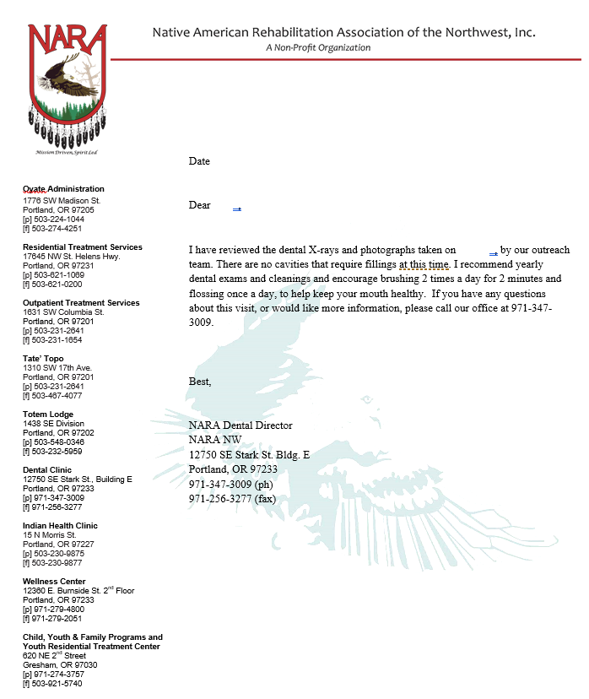
Example: Letter

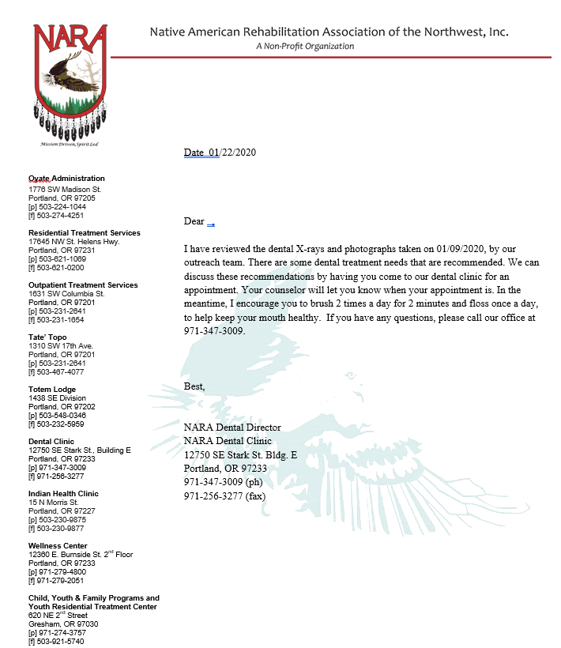

Example: Letter

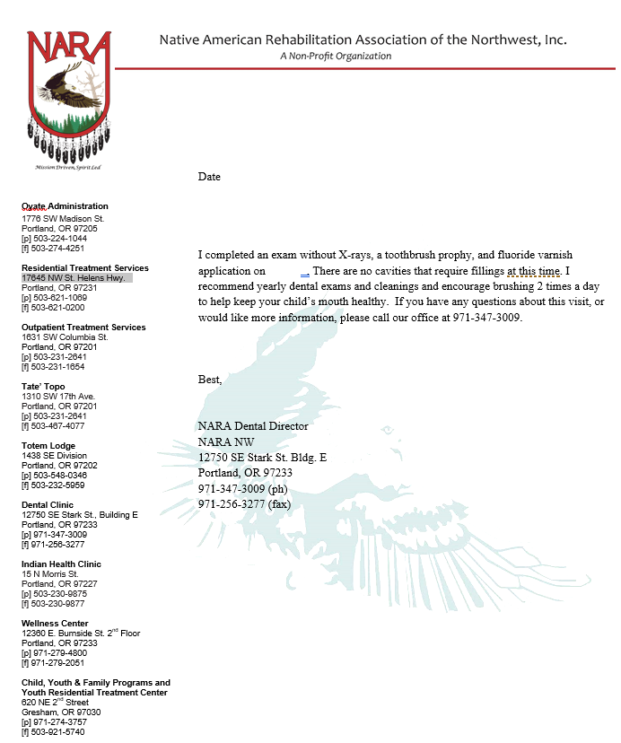

Post Treatment Survey

Were you receiving routine dental care prior to coming to NARA Residential?
YES NO

Having my dental treatment needs addressed and/or dental treatment completed, while in a recovery program has been beneficial to my sobriety.

Strongly agree Agree N/A Disagree Strongly Disagree

Receiving dental treatment onsite helped reduce my dental anxiety?

Strongly agree Agree N/A Disagree Strongly Disagree

Please rate the level of dental anxiety you had at your first dental appointment. 0 being none, 5 being severe

0 1 2 4 5

Please rate the level of dental anxiety you experience now that you have had dental work. 0 being none, 5 being severe

0 1 2 4 5

Receiving dental care while in recovery has made me more motivated to continue with routine dental care outside of treatment.
Strongly agree Agree N/A Disagree Strongly Disagree

Screening Protocol Guidelines

- Must have a signed consent
- Be sure to check that children can have fluoride before applying
- Complete screening report for guardian, attach dental clinic flyer (if not an established PT)
- Track children seen and what was done
- Return any new signed consent forms and tracking sheet to Sally (do not give to front office)
Example: Consent for School Based Treatment

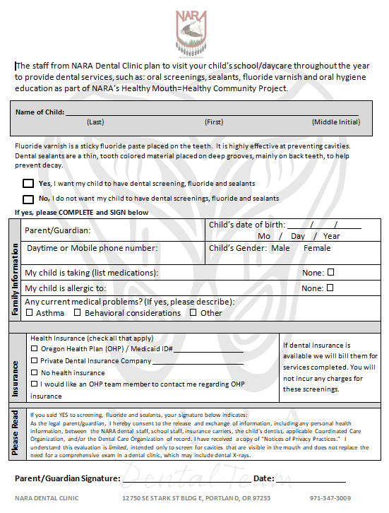
Example: Consent for Community Event Based Treatment

Consent for Oral Screening and Fluoride
As part of NARA’s Healthy Mouth = Healthy Community Project NARA’s dental team would like to provide you with a free dental screening and fluoride treatment. A qualified provider will screen for cavities, place fluoride varnish and provide education on proper brushing, flossing, and nutrition for a healthy mouth. You will incur no cost and any insurance you may have will not be billed.
*Fluoride varnish is a sticky fluoride paste placed on the teeth. It is highly effective at preventing cavities and reducing sensitivity.
By signing below I am giving consent for NARA dental team member to provide a dental screening and apply fluoride varnish.
I understand this evaluation is limited, intended only to screen for cavities that are visible in the mouth and does not replace the need for a comprehensive exam in a dental clinic, which may include dental X-rays.

Patient Name (please print) Gender (M/F) Patient Date of Birth
Signature Date
Printed Name Relationship to patient
This consent shall be considered in effect until rescinded or revoked

Example: Report for Treatment Completed for Guardians

Screening Report
Today your child, ___________________________, was seen by a qualified provider from the NARA Dental Clinic. He/she received the following:
___ Screening ___ Cleaning ___ Fluoride ___ Sealants
We recommend follow-up as indicated below:
___ Urgent need to seek dental treatment; multiple or large cavities appear to be present.
Please call (971) 347-3009 to schedule with NARA Dental or contact your child’s current dentist
___ Cavities appear to be present; should follow up with a dentist soon.
Please call (971) 347-3009 to schedule with NARA Dental or contact your child’s current dentist
___ No visible cavities noted at this time; recommend exam and films with a dentist
___ Child would not allow screening today. If you notice any discolored spots or child complains of pain, please call
(971) 347-3009 to schedule with NARA Dental or contact your child’s current dentist for an exam

NARA DENTAL CLINIC 12750 SE Stark ST BLDG E Portland, OR 97233 971-347-3009

Example: Aftercare Instructions for Guardians for Treatment Completed Offsite

Aftercare Instructions for Sealants
Your child received sealants (a protective coating placed on the molars to help prevent cavities) today from a licensed provider with NARA Dental.
Your child may notice that the tooth feels different, possibly high, because of the new sealant. The teeth and bite will feel normal again in a couple of days. Your child should avoid sticky, crunchy, or hard foods for the remainder of today. Sealants do not prevent all decay. Brushing 2 times a day, flossing once a day, and routine dental visit are still needed to protect your child’s teeth.
If you have any questions please call NARA Dental at 971-347-3009.

Supplies for Screening Box

- Sani-Wipes
- Gloves-Small, Medium & Large
- Mask
- Eye wear & light
  - Extra AAA battery for light
- 2x2- 1 pack
- Hand sanitizer
- Fluoride Varnish
- Toothbrush, toothpaste, floss, Biotene, denture brushes
- Appropriate educational books (Dry mouth, Diabetes & Perio, Sealants, Healthy Baby)
- Stickers (if age appropriate)
- Clipboard
- Pens
- Highlighter
- Post-its or notepad
- Paper clips
- New patient paperwork
- Screening report forms
- Dental clinic flyers
- Laptop/power cord/wireless router
- Educational sign in sheet
- Lock bag
- List of clients to be screened
- Blood Pressure Cuff
- Thermometer
- Appointment Cards
- IO Camera
- Nomad
- Sensor
- X-Ray sheaths
- X-ray tabs

Sealant Supply List

- Portable Chair
- Tititrator
- Fuji
- Clicker/dispenser
- Fluoride varnish
- Disposable mirrors
- Cotton tips
- 2x2
- Floss
- Mask
- Gloves
- Gowns
- Safety glasses-provider & patient
- Light
- Hand sanitizer
- Caviwipes
- Toothbrushes
- Stickers
- Post sealant instructions
- Lock bag
- Screening forms
- Pen
- Clipboard

