Baby’s first Year
There are things you can do that support development of skills and good health.
LEARNING
The first years of your baby’s life are all about learning. Your baby is learning:

  - he is safe and loved
  - who is familiar and who is a stranger
  - what he likes and dislikes
  - to stay calm
  - to move his body
  - to communicate

What you can do to support learning:
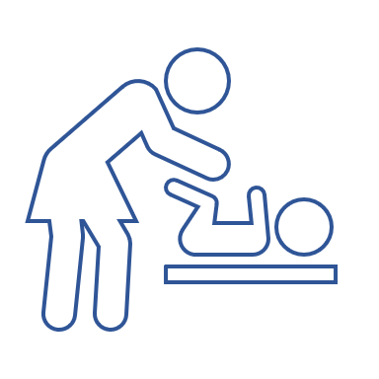
LOVE AND TOUCH
Give your baby LOTS of love, kisses, hugs, and gentle touches. Positive experiences make your baby feel safe and loved, can actually change the shape of your baby’s brain, and improve their ability to learn.

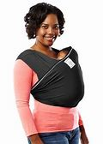
HOLDING & CUDDLES
Hold and carry your baby frequently. Your baby was “carried” constantly before she was born. Most babies still love to be held, carried, and rocked.

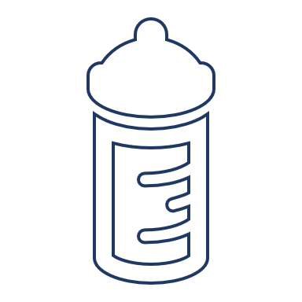
RESPONDING TO NEEDS
Respond to your baby when he cries. Crying is baby’s way of communicating needs.
Try: ♥ Feeding ♥ burping ♥ diaper change ♥ cuddle ♥ play ♥ sleep
Respond to your baby’s cries with love, even if you cannot solve their “problem.”

PLAY TOGETHER
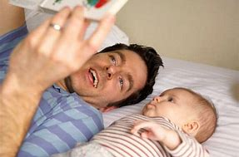
Play with your baby, face-to-face, every day. Babies learn best from a parent, not shows or even toys. They learn by watching you, playing with you, and by trying things out with your support.

Baby’s first Year
There are things you can do that support development of skills and good health
TURN OFF SCREENS
Turn off TV and screens like your phone or a tablet. Screens can sometimes keep a baby interested or quiet, but can change the way your baby’s eyes and brain develop, which may make it more challenging for him to learn as he gets older. Families with a TV on in the background tend to talk less to baby, which can impact learning to talk.

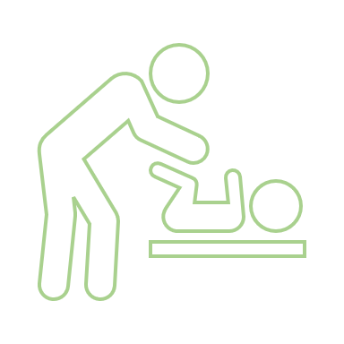
TUMMY TIME & FLOOR TIME
Babies need to spend LOTS of time on a safe, flat surface, like a blanket on the floor. When baby plays on her back and on her tummy, she learns to move her hands, arms, legs, and body. Spend a few hours each day playing on the floor with your baby.
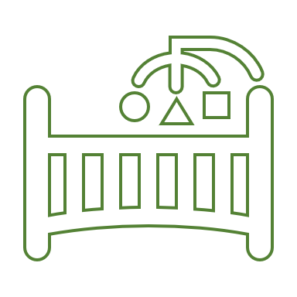
USE LESS PACIFIER
Limit pacifier use to naps and bedtimes. You may use a pacifier at first to help your baby calm and sleep. It can be tempting to use a pacifier frequently whenever baby cries or screeches. However, pacifiers can prevent your baby from learning to use his voice and face to communicate. Put the pacifier away when baby is awake and playing.
TALK, READ, SING
Talk, read, and/or sing to your baby often every day. The more words a baby hears spoken by a person who is face-to-face (not on TV or screen) over the first three years, the more easily he learns to talk and communicate. Even if you don’t think your baby understands, tell her what you are doing, sing to her, and read books with her daily.
TAKE CARE OF BABY’S TEETH
Brush your baby’s teeth, keep bottles out of the crib, and visit the dentist. Your baby’s teeth are very important for your baby’s health. Taking care of your baby’s teeth from the start helps prevent painful and expensive treatment later and sets your baby up for healthy teeth for life.
Food Insecurity
If you need support with feeding yourself or your family, consider these options:
Women, Infant, and Children (WIC)
A free program that helps families get free and reduced cost foods & other services.
How do I get it? Call 211 or text “health” to 898211 to find your local office. OR go to “Find a WIC clinic or store” at www.healthoregon.org/wic
The WIC office nearest us is at 254 N. 1st Ave. in Hillsboro (97124)

Supplemental Nutrition Assistance Program (SNAP)
A free program that helps families get free and reduced cost groceries.
How do I get it? Apply online at Oregon.gov and type “snap” into the search box.

Temporary Assistance for Needy Families (TANF)
A program that provides cash assistance to low-income families with children for basic needs, like food, clothing, shelter, and utilities.
How do I get it? Apply online at Oregon.gov and type “tanf” into the search box.

Local Food Banks
There are many places in Washington, Multnomah, Clackamas, Columbia, and Yamhill counties that give free food. These places are often run as part of a church but you do NOT have to attend the church or believe in the same religion to get food.
Most places will offer 1 or more of the following:
- A food box, with different types of groceries selected for you OR
- A pantry where you can pick the items you want and need OR
- A free meal
How do I get it? Use the “Guide to free food” handouts from Oregon Food bank to find sites near you. Call before you visit to make sure they’re open & check if you need to bring anything, like proof of address.

Calming and Communicating with Your Baby

All babies need:
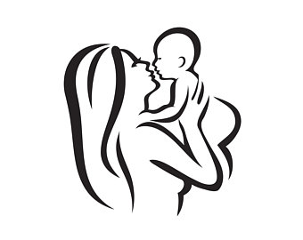 | LOVE  Holding  Cuddles, Kisses
FOOD
Breastfeed or bottle-feed often
Watch for feeding cues
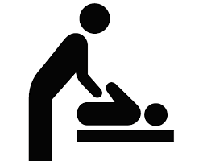 | CLEAN DIAPERS  Change often when wet or soiled
PLAY
Place baby face to face on your lap or blanket
Make faces, funny sounds, blow raspberries, sing
Play with fingers and toes or use toys/rattles
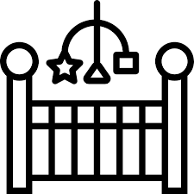 | SLEEP  Swaddle, hold, and rock until drowsy  Shush, sing quietly to baby, or use “white noise”  Place on back in crib  Keep room dark and cool  If baby still not sleeping - walk in carrier or stroller
When my baby cries, I can
- Feed my baby
- Give my baby something to suck (pacifier, finger)
- Change baby’s diaper
- Swaddle, snuggle, and gently rock my baby
- Sing to my baby
- Take a break
  - Put my baby down in a safe place and let him cry for a while
  - Let someone I trust take over for a while
  - Take deep breaths
  - Put on some quiet music to distract myself
  - Remind myself that crying won’t hurt my baby, and he will outgrow this phase

ACTION PLAN
When I am overwhelmed, I can:

1. __________________________________________________________________

2. __________________________________________________________________

3. __________________________________________________________________

During my down time, I relax by:

1. __________________________________________________________________

2. __________________________________________________________________

3. __________________________________________________________________

If I need help, I can call:

1. __________________________________________________________________

2. __________________________________________________________________

3. __________________________________________________________________

Your Child’s Teeth
There are steps you can take that lower your child’s risk for cavities.

PREVENTION IS BEST. Your mouth leads to the inside of your body and the nerves of the teeth run directly to the brain, so cavities in teeth can have a big impact. Fixing cavities in young children may require putting the child to sleep, which has risks. |  | Simple steps can keep your child’s teeth healthy. It’s important these actions become daily HABITS.  - Brush teeth 2 times every day- in morning & at night  - Reduce the amount of sugary foods/drinks your child has (especially between meals.)

Brushing
Most of us parents know we should brush our child’s teeth twice per day but it’s easy to forget to do it. First step in changing this is to decide why it’s important for you. Check all the reasons that are important to you!

I know that infections in the mouth can be serious trouble for my child’s health.
I don’t want my child to have pain in his/her teeth.
I want my child’s teeth to be better and healthier than my own.
I don’t want to have to bring my child back for expensive or difficult dental treatment, like fillings.
I know that kids who have cavities in their baby teeth often get cavities in their adult teeth.
I know that kids who brush with parents tend to grow into adults who take care of their teeth.
I don’t want my child to miss school or me to miss work to get cavities filled if I we can prevent it!
OTHER:
Making it a HABIT
1.
Set a plan to change by filling in this line: Every morning after I __________________________, I will brush my child’s teeth. Every night after I __________________________, I will brush my child’s teeth.
2.
Put your child’s tooth brush in a place that you cannot miss. If you often forget to brush before bed, for example, you can keep it next to your child’s bed so you’ll see it and it will remind you to use it!
3.
Reward yourself when you remember to do your new habit every day for a week. Working towards a reward can make us more likely to do something new before it becomes a habit.

Avoid grazing  The foods your child eats between meals can have a bigger impact on your child’s teeth than what they eat at meals. Especially if the food is sugary, like crackers or sticky, like fruit snacks. Offer fruits, vegetables, nuts, or cheese. |  | Keep bottles out of bed  Breastmilk, formula, and other types  of milk are high in natural sugar. When a child drinks milk before bed or during the night without brushing after, that sugar can eat away at your child’s teeth all night long. Keep milk at the table, brush teeth before bed, and only offer water during the night. |  | Regular care  Did you know if you catch a cavity early, you may be able to help it heal without a filling? This is a reason why it is so important to check in with your dentist every 6 mos.

